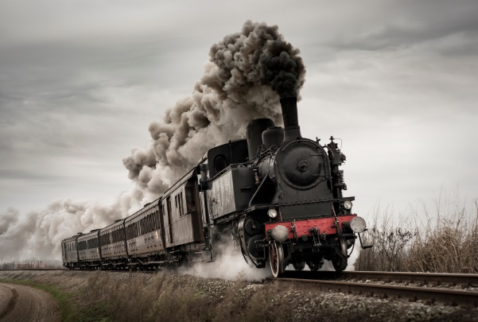
June 2023
Congleton Players
www.congletonplayers.com
The Railway Children
By Edith Nesbit
Adapted for the stage by Mike Kenny

We are thrilled to introduce the first play of our 2023/24 season. It is the well known and loved play “The Railway Children” to be directed by Howard Ball and assisted by Linda Davenport.
It will be performed at Daneside Theatre Tuesday 3rd to Saturday 7th October 2023. The reading will be in the bar on Monday 26th June at 7.30pm. and auditions will also be in the bar and lower foyer on Monday 3rd July, again at 7.30pm. All are most welcome to attend the reading, even if you are just familiarising yourself with the play. The bar will be open for the reading!

Famously filmed, this story of a prosperous Edwardian family - mother and three children - forced into near-penury in the rural north of England captures the anxieties and exhilarations of childhood with great tenderness and insight.

As Mike Kenny says of his remarkably faithful adaptation, 'You don't need a real train to perform this play… the most powerful prop is the imagination of the audience, the most effective tool the skill of the actors.' So, this version of The Railway Children is definitely different, The 4th wall is broken sometimes, but very strictly to script only.
Please watch the link. https://youtu.be/B7mOH35E2a8

THE RAILWAY CHILDREN
ROBERTA (BOBBIE)
Roberta is 12 years old. She has a brother named Peter and a younger sister named Phyllis. She is fondly known as Bobbie in this novel. She is the eldest of the three. One of her characteristics is, she is a very persistent person. She doesn't easily throw in the towel when the odds seem to be against her.
There are many incidences in the script where we can see her persistence, we can see how determined she is in getting the things necessary for her mother's recovery when her mother is ill. Her persistence pays off when the old gentleman gave the things needed for her mothers recovery. Perks is not happy with people giving him presents. He is worried that people would laugh and make fun of him. Bobbie persistently reasons with Perks about the good intentions of the village people giving birthday presents. She is persistent even when her mother has given up. She secretly writes a letter to her friend, the old gentleman, asking for his help to clear her father's name. In the end her father is released from prison.

PETER
Peter is Roberta's brother. He is the second child in the family. Peter is a very brave and smart young chap. He wants to be an engineer when he grows up. He has a knack for railway engines. He is overjoyed when his father gives him a steam engine for his birthday. One distinct characteristic of Peter is his sharp wit.
It is Peter who has the idea of using something red in colour to wave and stop the train from meeting a certain disaster. He cuts his sisters' red petticoats into six pieces and put them on to sticks. Peter, together with his sisters, waves at the coming train until it stops.
Peter is honest in giving the idea of asking the village people to give gifts for Perk's birthday. He tells his mother about their true intention of giving Perks the presents. Many people give gifts for Perks birthday party.

PHYLLIS
Phyllis is the youngest child in the family. She is the cutest of the three. She is quite a bubbly character. She is very naive and insecure. She is also very sensitive but easily forgiving. We can see there is brave side to Phyllis. She, together with her elder sister and brother, manages to stop the train from meeting with a terrible accident.
Phyllis feels very insecure when they move in to their new house in the countryside. Phyllis becomes very sensitive when Perks refuses to accept the gifts the children have brought to him. She is so hurt by Perks’ words that she starts to cry. In the script we can see how loving, caring and helpful Phyllis is.

MOTHER
Mother is a homely type. She spends most of her time at home, playing with the children or reading stories to them. Usually, she reads the stories she wrote to them. She is a very protective woman. She protects her children from worrying or feeling sad about their father. She does this by not telling them what actually had happened to their father. She also tells them that they need to play at being poor for a while, in order not to cause more anxiety on them.
We can see how resourceful she is. Mother writes stories and sells them to put some food on the table.
We can see that Mother is a very proud person. Although they are poor, she strongly discourages her children from telling people that they are poor and asking strangers to help them.
She is also a very caring and loving Mother. She is always ready to play with her children and read stories to them. She teaches her children their lessons as they have stopped, she takes in the homeless and the injured boy into her house and nurses him to health. Large part.

FATHER
The children's father works in a government office. He is a civil servant. He is an honest and hardworking man. He is wrongly accused of being a Russian spy and sentenced to 5 years in prison. We can see how tolerant and wonderful he is. He never gets angry at the children nor at his wife. The children love their father very much for he is always happy and ready to play games with them. When Peter shows him his broken steam engine, father looks at it carefully and smilingly tells Peter that there is hope (optimistic) that his steam engine could be repaired. He is also a grateful man. ("Yes', said Father.' It's him I must thank.'). Father is grateful for his release and wants to thank the old gentleman for helping him to clear his name and secure his release from prison.

ALBERT PERKS
The station porter, and a friend of the children. He enjoys their company, but his pride sometimes makes him stuffy with them. He lives with his wife and their three children and loves them all very much. They are quite poor but proud. Perks is very knowledgeable about the study of railways and other areas. He is proud, hardworking, reasonable and responsible.

OLD GENTLEMAN
He is an extremely intelligent and wealthy man. Well-spoken and very caring. He is the director of the Great Northern and Southern Railway (GN&SR), who befriends Bobbie, Peter and Phyllis and helps when their mother is sick. He is instrumental in freeing Father, and in locating Mr Szczepansky's family. He is the grandfather of Jim.

DOCTOR FORESTER
A country physician. He is rather poor, but nevertheless provides affordable care for Mother during her illness. Extremely passionate about his job.

MR SZCZPANSKY
A dissident Russian intellectual, imprisoned in Siberia for his views, who escapes to England to seek his wife and children. He is worn down battered with life but still strong with the passion to find his family.

JIM (schoolboy)
Posh spoken and very well-mannered Jim is the grandson of the Old Gentleman, whom the children rescue when he breaks his leg in the railway tunnel during a paper chase.

MRS PERKS
Caring mild mannered wife of Albert Perks. Poor and proud caring and loving. She loves Perks even though sometimes he puts his job first.

MRS VINNEY
Chatty and friendly always has a giggle. She is the housekeeper at The Three Chimneys.

The children are played by adults, but we will need children for some scenes.

We look forward to hearing from you. Both the reading and auditions are open to all who are interested, whether a member or not.
For further information please contact Howard on 07718210156 or email howardnball@gmail.com

Annette Bradley(nettybradley47@gmail.com) 07850844113
Chair

